DAY API 5 (VARIABLES)

- SCRIPTS:

- Pre-request: open any request- scripts – pre request

Note: This request will run before starting the request
4 Levels:
- Workspace
- Collection
- Folder
- Request

Create new collection – create new folder - create request in folder
Step 1: In collection – request - script – pre request
console.log("pre request at collection level") // sysout

Write this code in all three then run the code from collection level
CYCLE OF EXECUTION
Pre request -> Request -> Response -> Post response

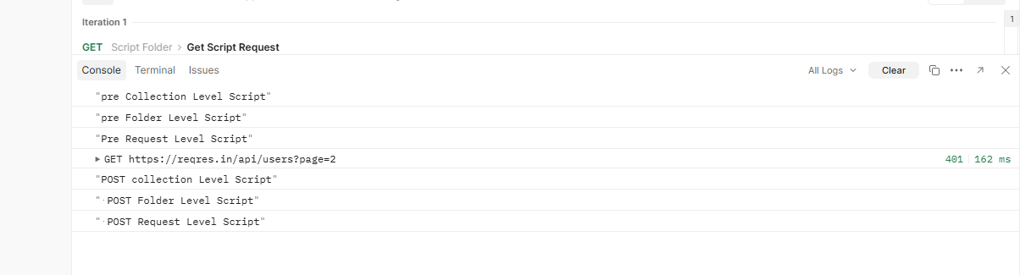

Note: In simple language if we need to run the pre request code in all the folder then write the pre request code in collection because in collection only we will maintain all the folders. If we need to run pre request code of all request then write code in folder level

- POSTMAN CREATE VARIABLES:
What:
To store the common data this is like box where we can store the data’s
Why and where :
In feature we need to modify: For EG: we can take the URL which we will write in all 4 requests if we need to change the URL in feature we don’t need to change in all 4 requests we can just change in only that URL variable not only URL we can create even more
Type: this is all only for 1 workspace
- Global -> accessible in full respective workspace
- Collection-> accessible only with specific collection
- Environment-> accessible all collection but want to switch
- Local-> accessible only one request level alone
- Data-> external file text/csv... (latter)

- How to create GLOBAL Variable:
When we create global variable we can use every were in the respective workspace collection, folder and requests every were
Respective workspace – right corner 4 box variable – global - add - save
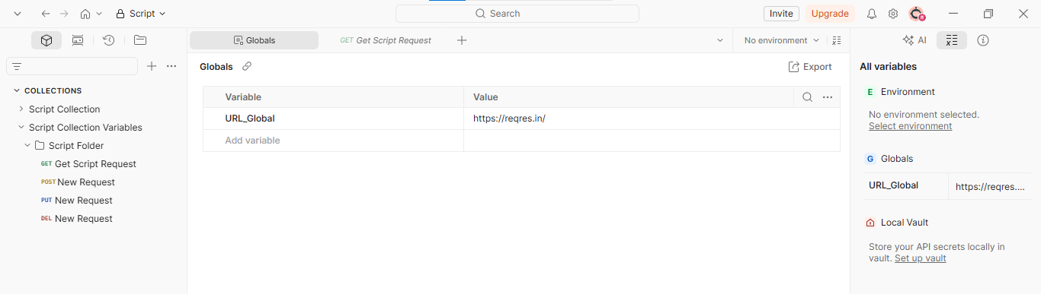
BEFORE GET URL: https://reqres.in/api/users?page=2

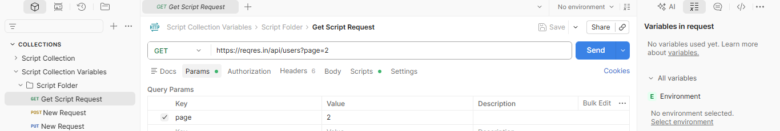
AFTER GET URL {{URL_Global}}/api/users?page=2
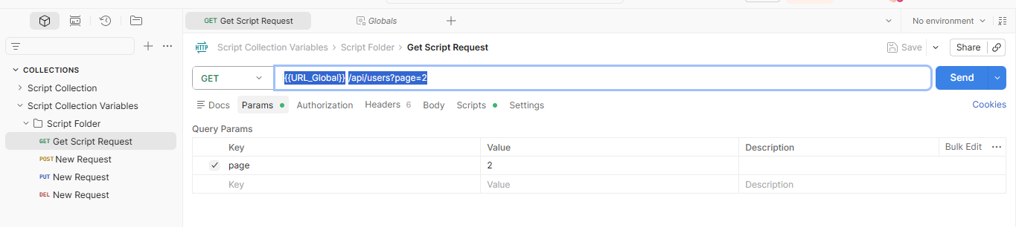

- How to create COLLECTION Variable:
Note: This variable we can use only within the respective collection only we can call this variable in all the requests inside that respective collection not outside the collection
Respective collection open – main page we will find variables
Follow same syntax {{URL_Collection}}/api/users?page=2
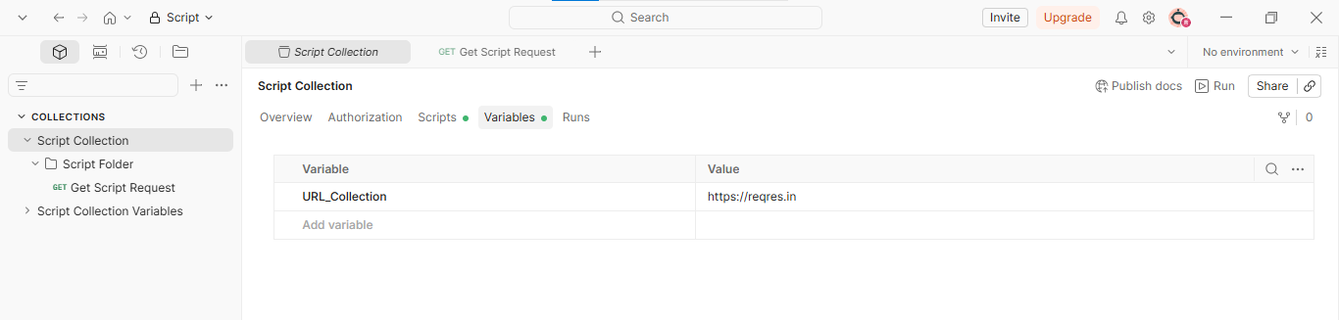
- How to create ENVIRONMENT Variable:
Note: In one collection we will create multiple requests now I need to execute the entire request from the collection in specific environment. We can create multiple numbers of environments. This is also global access we can use in any request in that workspace
Step 1: Create environment
Workspace – right corner 4 box – Select environment – create – name
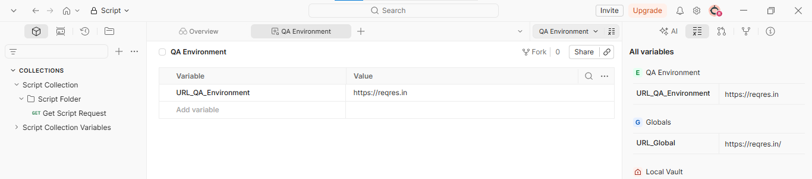
Step 2: Use this environment variable from QA environment by switching into that respective environment – in top right we will see environment dropdown the we have to select which environment we want to switch
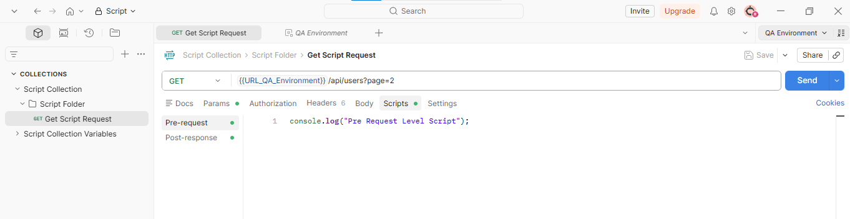
- How to create LOCAL Variable:
Note: we can use this only within one specific request we can’t use in another request in same collection also
Open any request – scripts – pre-request – write the variable code
//Local Varaible:
pm.variables.set("URL_GET_local","https://reqres.in/");

{{URL_GET_local}}api/users?page=2
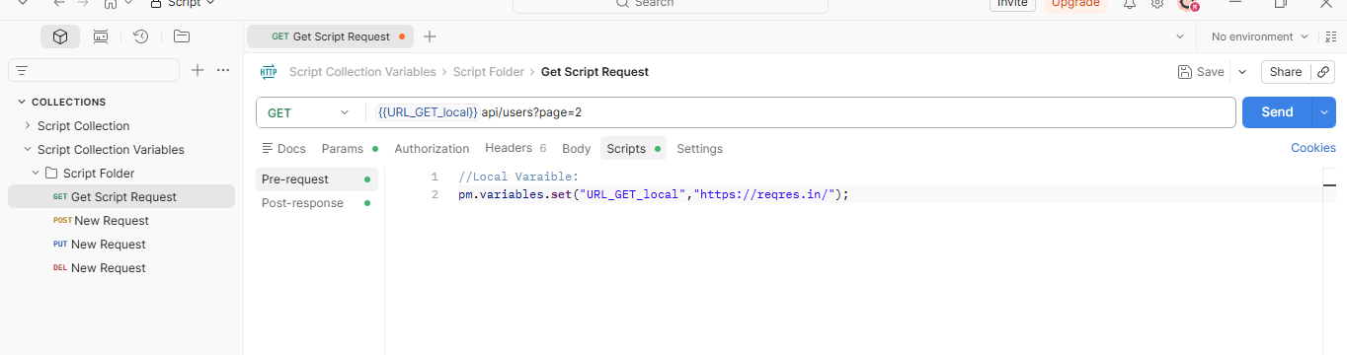
- How to create DATA Variable: this will learn later data driven class DAY 6
Note: We will create variable outside postman like we will create in text/csv file like that and import that into postman tool

As of now we create variable in 4 different places. But now what we going to do we going to write the entire valuable in local level in pre request scripts:
- How to create variable ising pre – request script .set will create varable
Step 1: Open get request – script – pre-request – write all variables
//Local Varaible:
pm.variables.set("URL_GET_local","https://reqres.in/");

//Global Variable:
pm.globals.set("User_ID","28");

URL at top:
Before: {{URL_GET_local}}api/users?page=2
After: {{URL_GET_local}}api/users?page={{User_ID}}
//Enviromant Varaible/ before select specific environment from top dropdown
pm.environment.set("User_ID_envi","28");

URL at top:
Before: {{URL_GET_local}}api/users?page=2
After: {{URL_GET_local}}api/users?page={{User_ID_envi}}
//Collection Variable: all request in same respective collection
pm.collectionVariables.set("User_ID_collection","28");

URL at top:
Before: {{URL_GET_local}}api/users?page=2
After: {{URL_GET_local}}api/users?page={{User_ID_collection }}

- Remove the created variables .unset will remove varable :
Note: after running the global variable in pre request now I have to remove that global variable permanently
Step 1: Now the global variable is in pre request page
URL: {{URL_GET_local}}api/users?page={{User_ID}}
pm.globals.set("User_ID","28");

Step 2: Now pre request will run before the test
Step 3: After running test now I want to remove the global variable permanently from global variable page. For that go to pre respond page put the below code
pm.globals.unset("User_ID");
pm.environment.unset("User_ID");
pm.collectionVariables.unset("User_ID");
pm.variables.unset("User_ID");

// this will remove global var after the test is completed running and no need to provide the value

- Want to print data’s of variables :
After creating variable in pre request page now come to pre response page type the below code it will get the data before deleting the variable
//Return the value of global variable
console.log(pm.globals.get("User_ID")); //print global var value
console.log(pm.environment.get("User_ID_env")); // print environment var value
console.log(pm.collectionVariables.get("User_ID_collection"));// collection value
console.log(pm.variables.get("URL_GET_local"));// print local var value

This will print the value in the console what we stored in user ID variable

